Shell Script Assignment

Mandatory:

1. Create a script named “myscript” in current directory to do the following. vi myscript.sh

a) display “hello user”

b) list files in current directory

c) name of logged in user

d) date

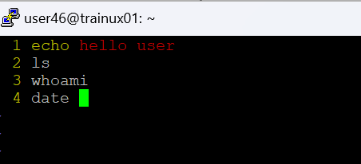

2. Add execute permission and Run the script from

a) current directory

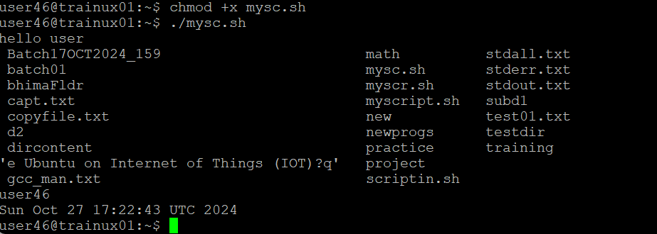

3. Create a subdirectory named “test” :

A: mkdir test

4. Change to “test” directory. Run the script “myscript” [Hint: You will have to update PATH to include the directory containg script to run script from any location].

export PATH=”$PATH:/home2/user46/d2/”



Optional Assignments:

1. Considering command line arguments are accessible using $<position> i.e

$0- for first argument

$1- for second argument…

write a shell script to concatenate all command line arguments using ‘_’ and display it as a single string.

Refer example below

$>./myscript.sh ABC DEF

Output:

ABC_DEF



